Capstone Design (2)

Proposal

|  |  |
| --- | --- |
| Date | 2019. 03. 10. |
| Team name | LAJI |
| Member1 | 20160237 Jisu An |
| Member2 | 20133096 Hyunjae Lee |
| Member3 | 20143954 Jinwoo Jeon |
| Professor | Sangoh Park |



Project Outline

Introduction

Cafés and restaurants have tables in each store and provide consumers with food and drinks. If the number of a group of consumers is large, the store that only has limited staff to work at the same time might get the wrong order information, and for that group, it can be cumbersome to pay individually. So, we intend to provide more practical and convenient integration. Each table has one unique QR code. The QR code allows consumers to access the website. One consumer (called a host) who will charge among a group of consumers can form his or her own group by creating an encrypted party. Once a party is created, the remaining consumers in the group can access that party and make menu choices through information that crawled through the menus in each store. After everyone, including the host, completes their personal menu selection, the host selects the group menu. Then, divide the amount for group menu by the number of people through the website and add that amount to the cost of settling the remaining consumers. Once added, the required amount of each member of the group will be remitted to the host individually via Toss. When everyone is done sending money, the web sends a message to the host that it is 'payable'. And the host can pay with his or her card. The ordering information of this party is sent to the POS of the store. Since different stores have different types of POS devices, the first step is simulated by replacing the POS screen.

Function

* All stores can have a common payment process
* Prevent order errors in advance and minimize the inconvenience of payment.
* From the perspective of sellers, various information can be analyzed through real-time table status.

Structure (지수)

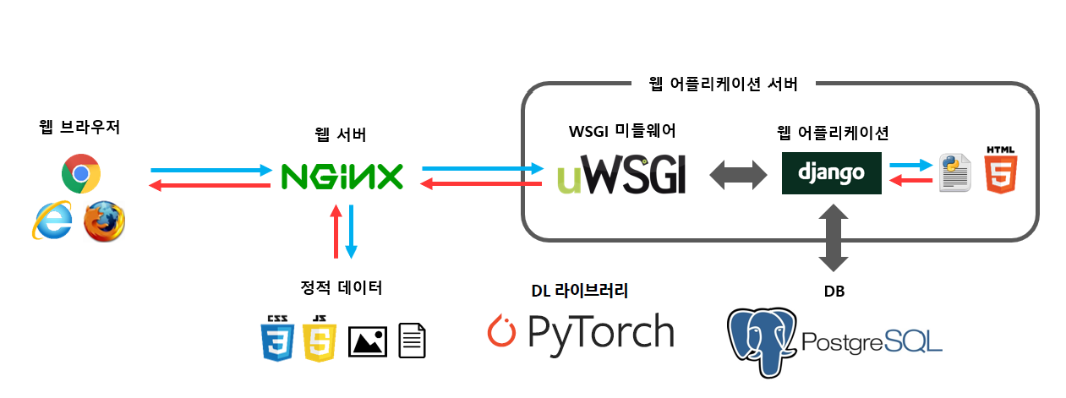

Roles and Schedules (진우)

Jisu An – 웹 크롤링, Toss Api

Hyunjae Lee – 소비자 웹UI, 판매자 웹UI

Jinwoo Jeon- QR코드 인식, Pos기 웹UI